Which of the following is true when adding rules to a form that was built using the built-in form module?

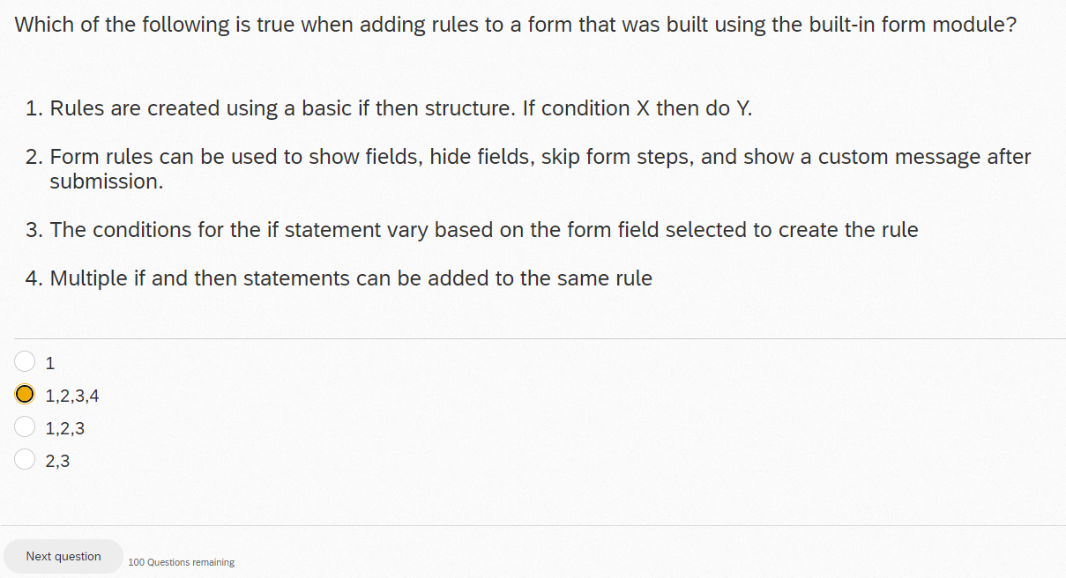

A custom widget designer is used:

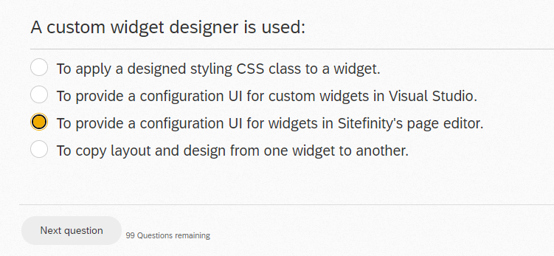

You want to expose a Controller property in a widget designer as shown in image: You are editing the widget designer view file and your goal is to expose the RootNodeId in a simple input element. What is the proper syntax you need to use?

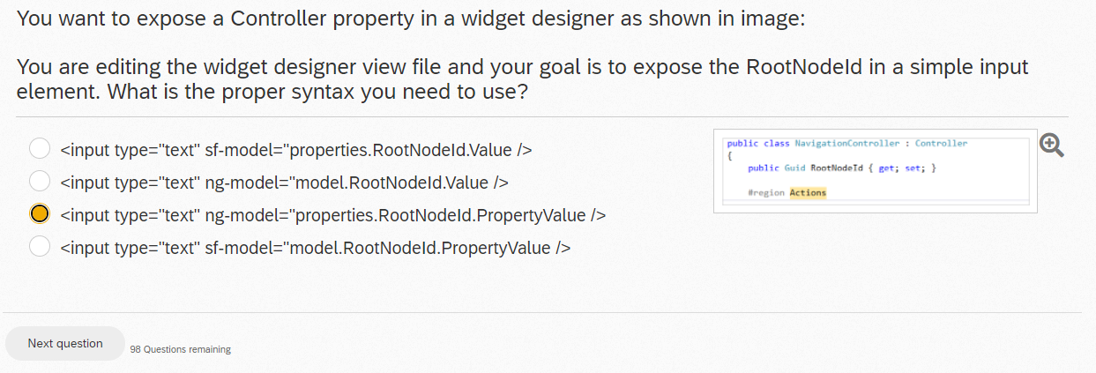

What will the following code accomplish?

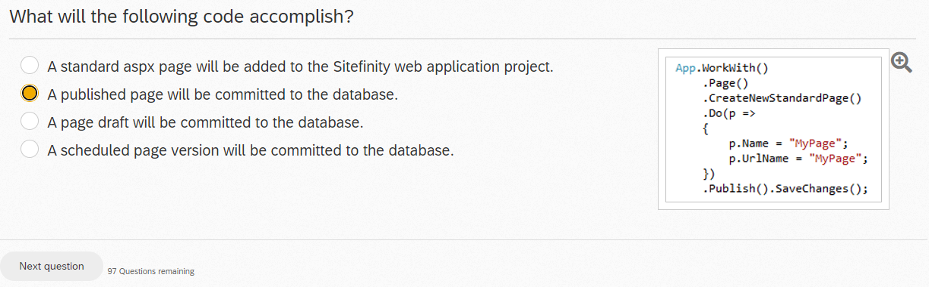

Which content lifecycle states are defined in Sitefinity?

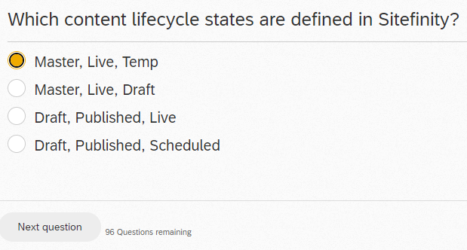

When multiple sites are used on a single instance of Sitefinity:

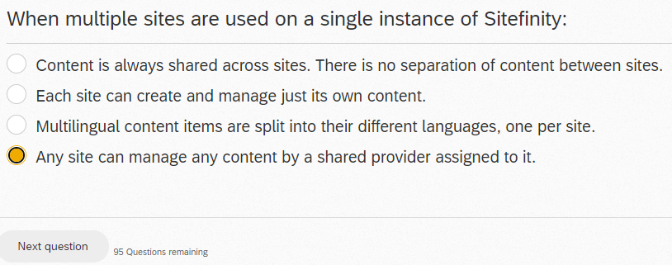

Which of the following is not a benefit of the new Sitefinity .NET Core renderer?

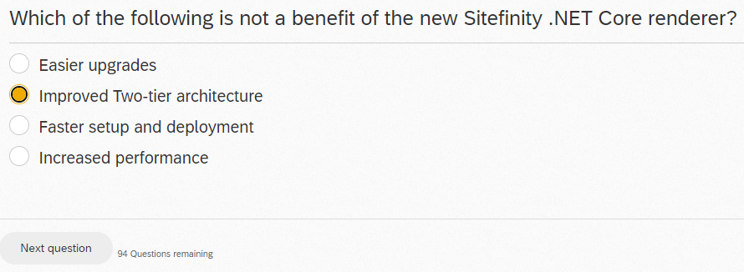

You want to use Resource Files on a custom MVC Widget to properly translate properties to different languages. What action should you take?

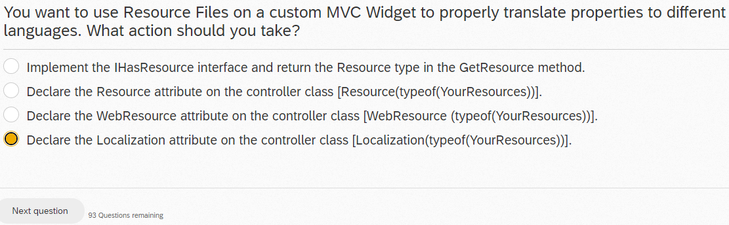

How do you package MVC widgets in an external class library assembly?

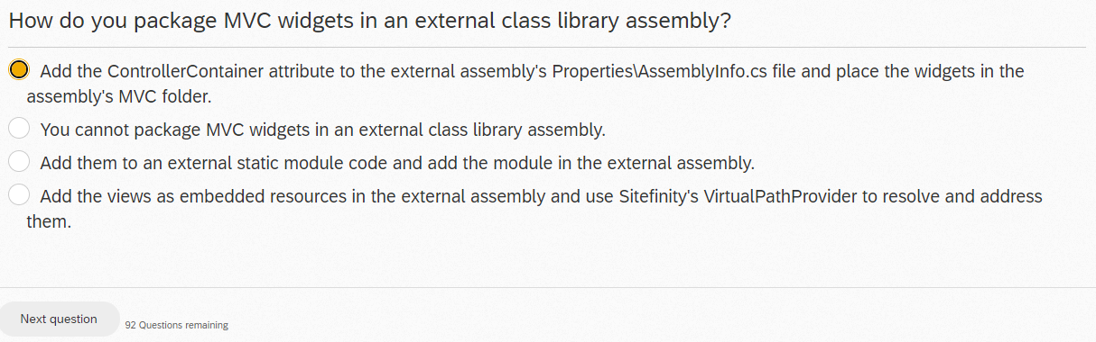

You have just successfully finished installing a new Sitefinity module that programmatically adds two new widgets and a new Role to the default Roles Provider. What configuration files are likely to be modified during the installation?

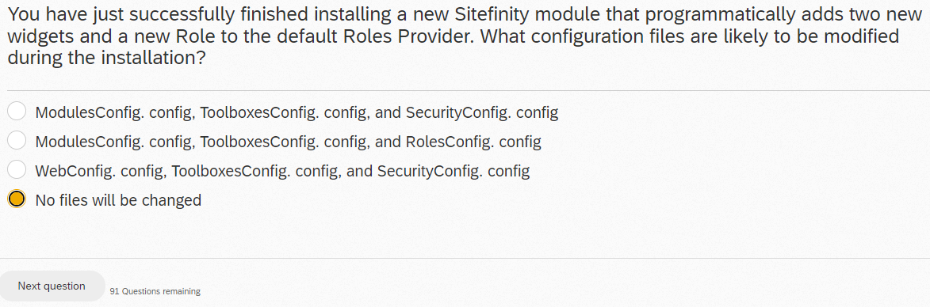

Which of the following are differences between managers and providers?

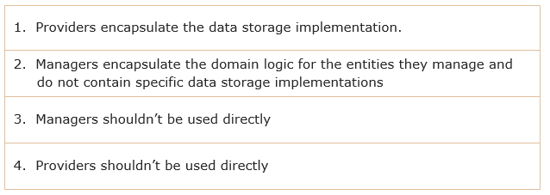

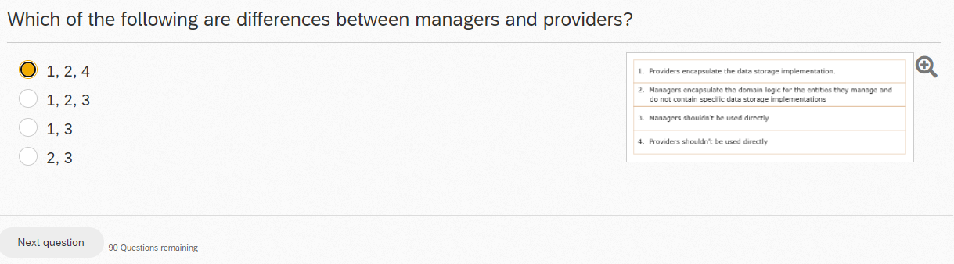

To associate a News content item with a tag programmatically a developer would:

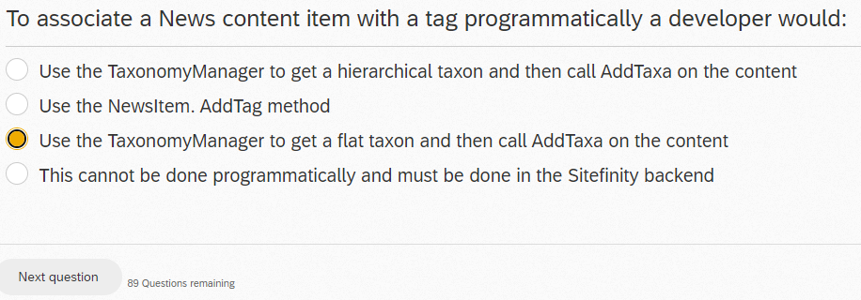

Which of the following translation services are available as a part of Sitefinity?

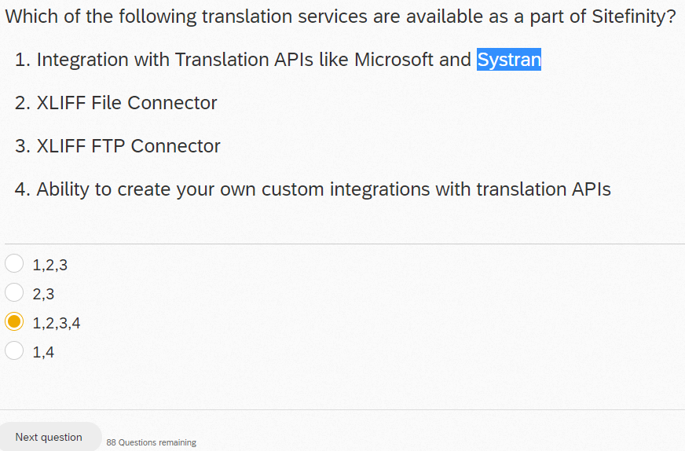

Connection strings can be stored inside which of the following files?

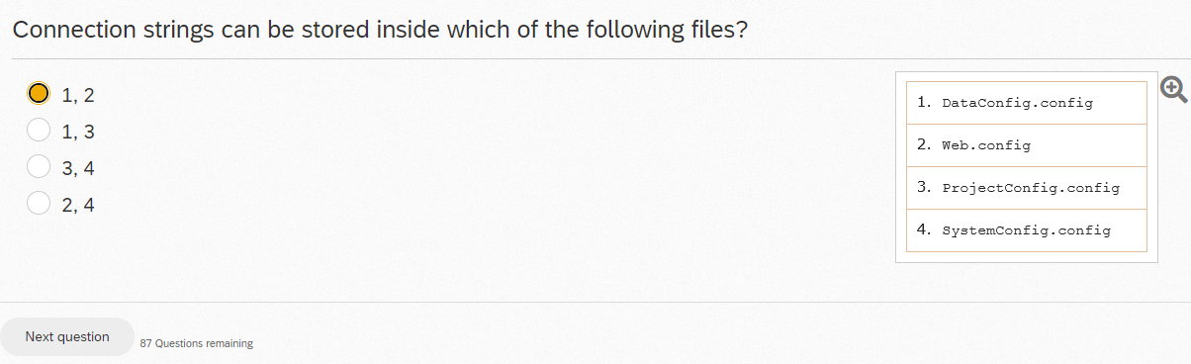

What folder should you use to store static asset files in the .NET Core Renderer?

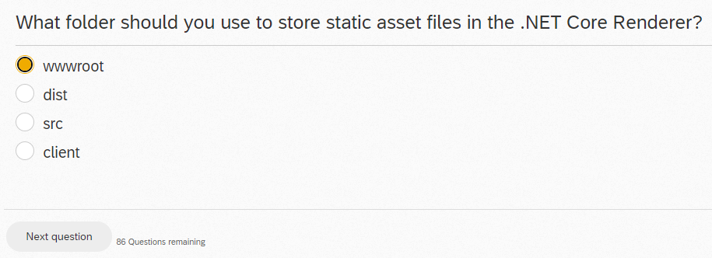

Dynamic content types created by the module builder are:

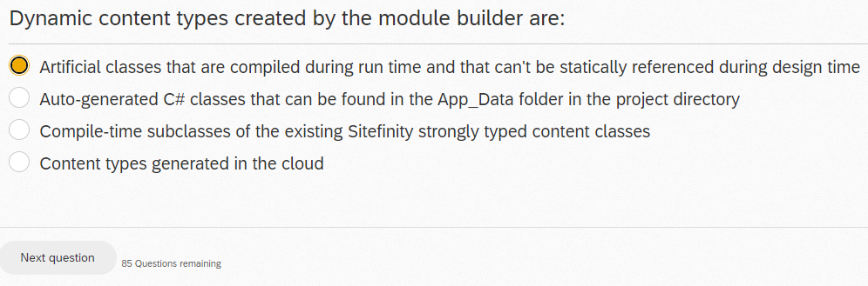

Which of the following NuGet packages are required to run the Sitefinity .NET core renderer?

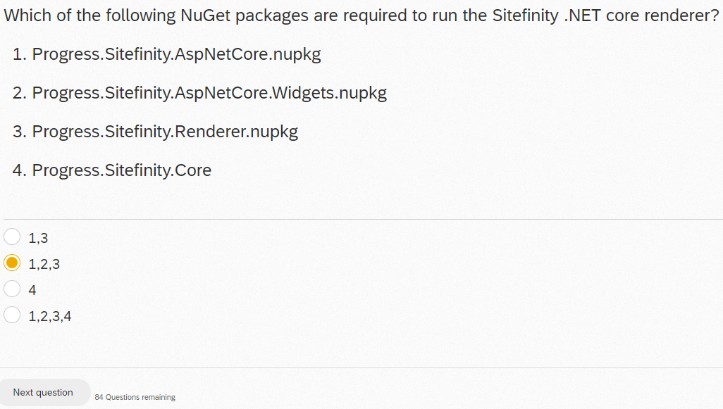

When creating a custom widget designer named "Custom" that has a custom AngularJS controller, what is the name you should specify as your controller when pushing it to the "designer" module within your Angular JS file?

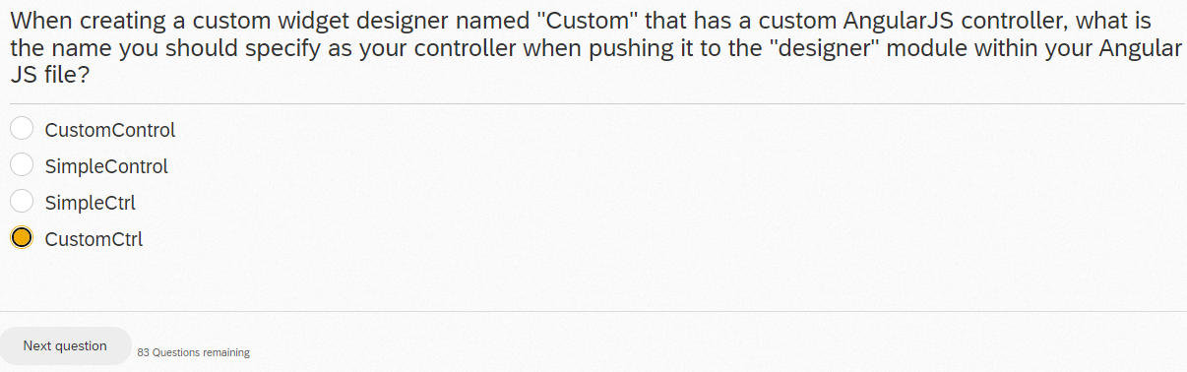

In order to customize a paragraph form field that a frontend user would use while filling out a Sitefinity form, a developer must do the following:

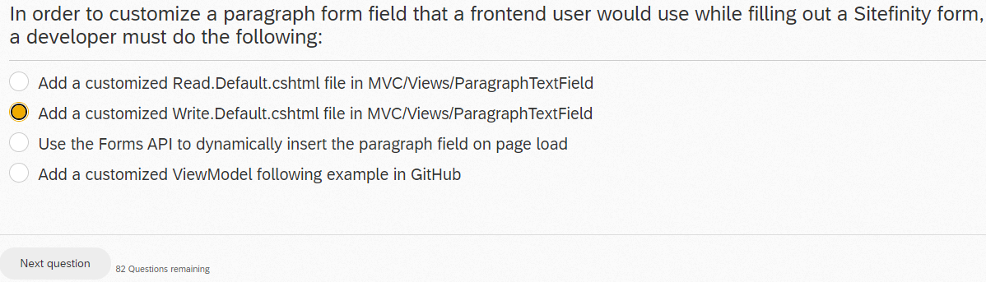

After entering the code below, the SetValue() method is not recognized by the compiler. How can you fix this?

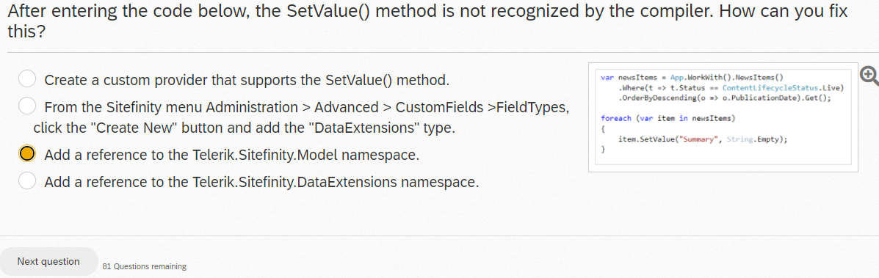

How personalization options could be enabled for a custom widget?

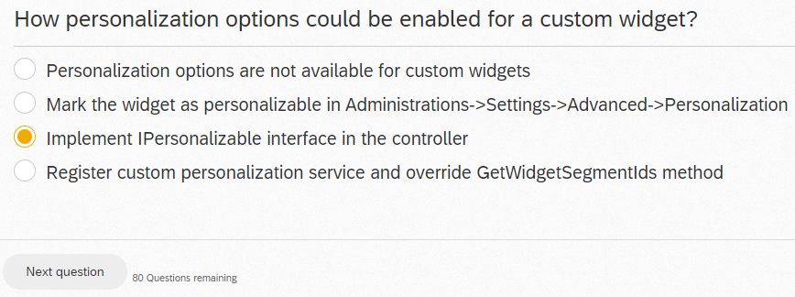

By default, the Change Owner command is only available for which content type?

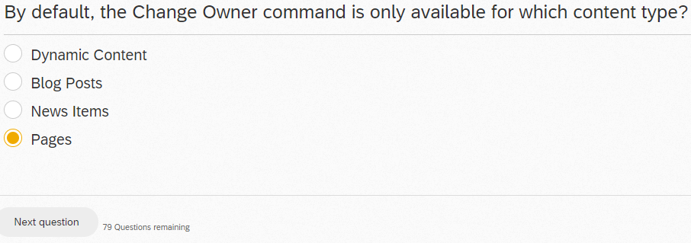

What attribute should you use in an Entity to allow the user to select the template for the custom widget?

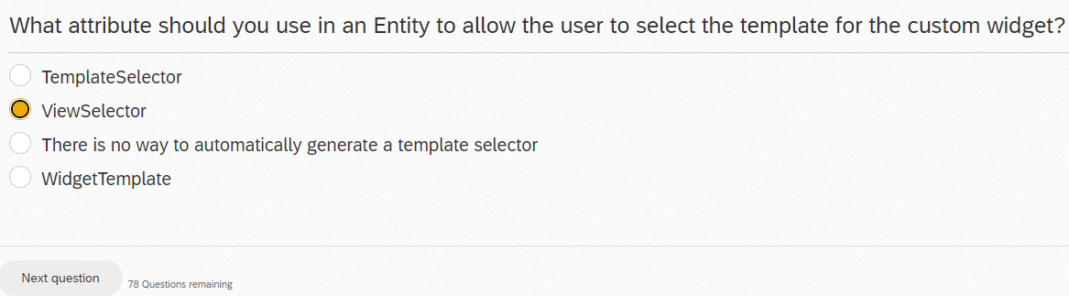

If you have customized the Admin App by using the sample repo provided by Progress, how do you install your customization in your Sitefinity site?

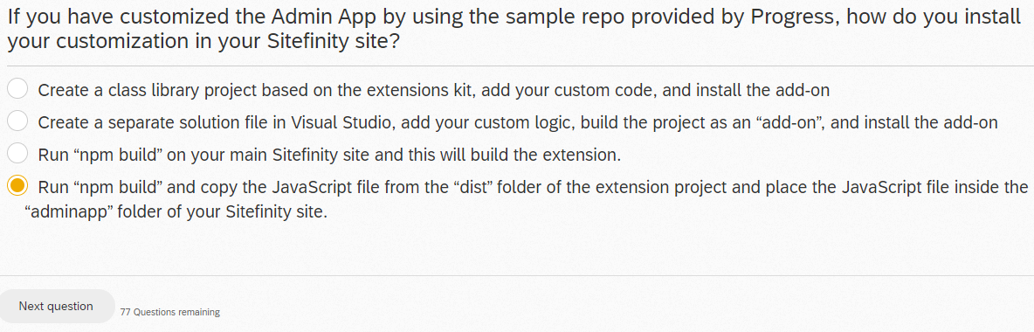

You want to create a Sitefinity MVC widget. What is the correct way of doing it?

Create a new Class that inherits from System.Web.Mvc.Controller

When do you need to call SaveChanges() on a manager instance? For example:

var man=PageManager.GetManager(); man.SaveChanges();

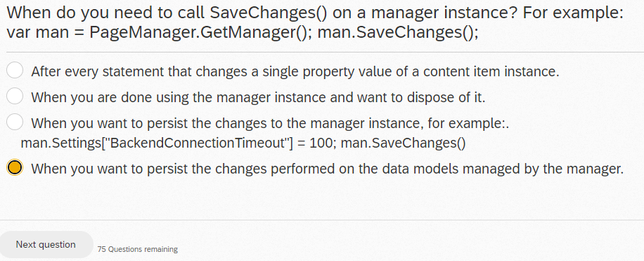

Which of the following statements about OpenAccess and Sitefinity is true?

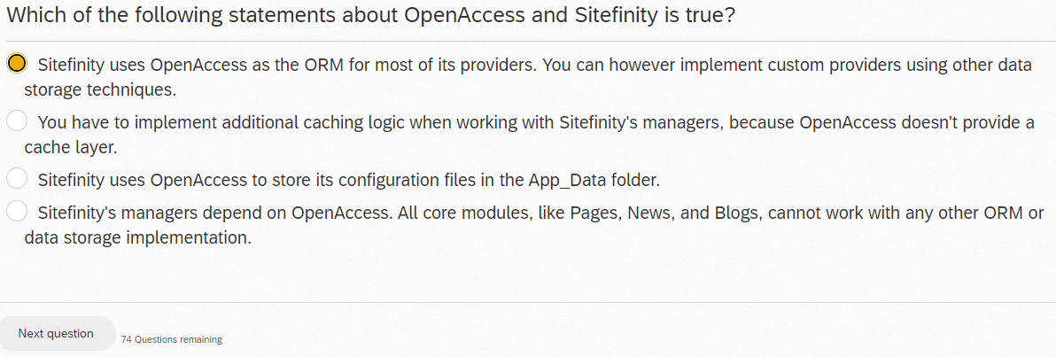

How does Sitefinity's precompiler tool help improve performance?

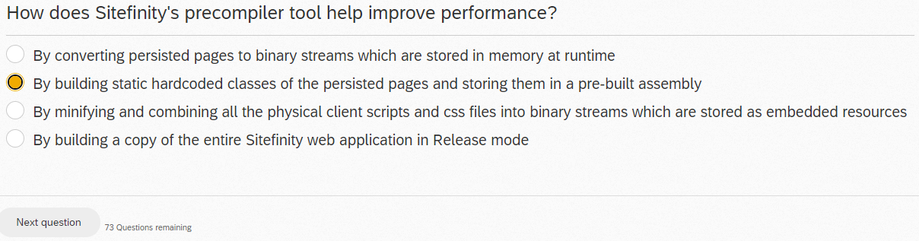

Which of the following statements represents a distinctive feature of the Sitefinity MVC implementation?

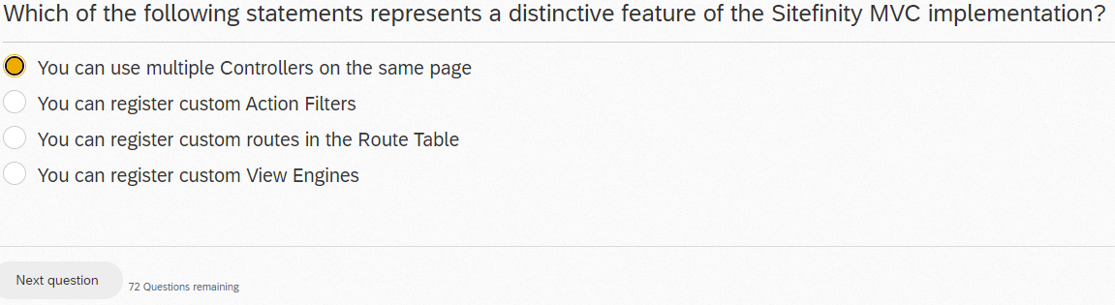

The widget designer's advanced mode:

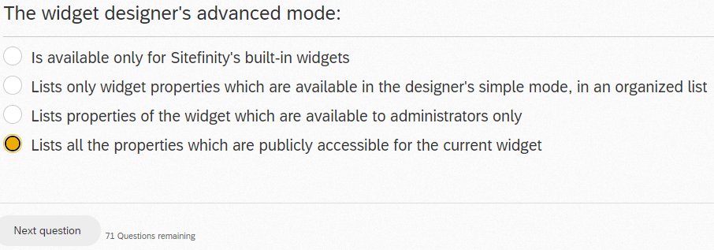

You are a user, registered in Sitefinity's backend as an editor. You browse the site and find a few typos on a single page. The typos are in separate areas of the page and of different content types. What are your options for correcting them?

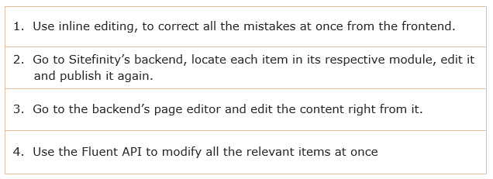

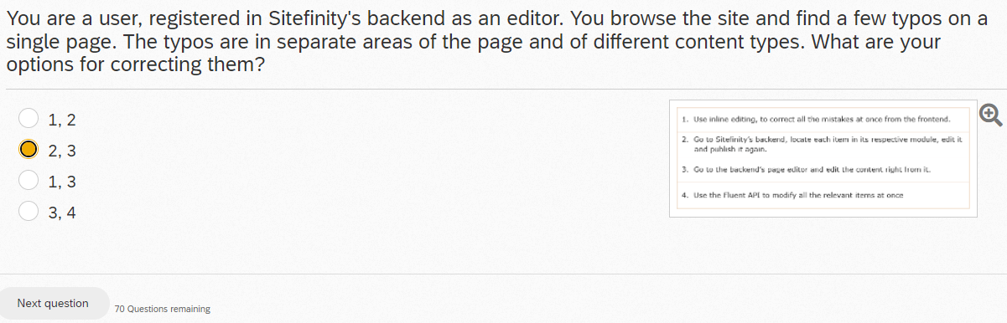

INCORRECT, try 1,3

Which of the following is not needed when creating a custom web services endpoint?

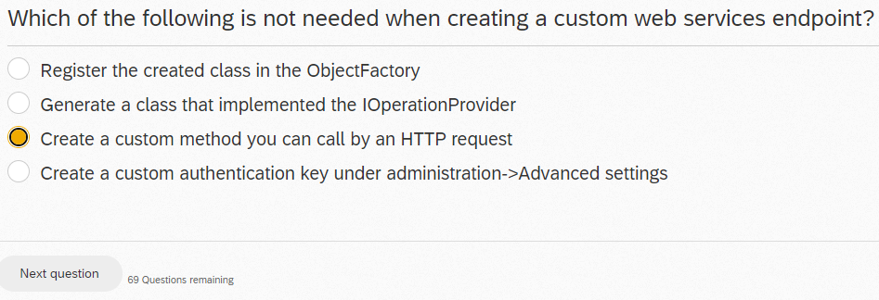

INCORRECT, try Create a custom authentication key under administration->Advanced settings

Where can you configure the CSS framework used in the backend of the .NET Core Renderer page editor?

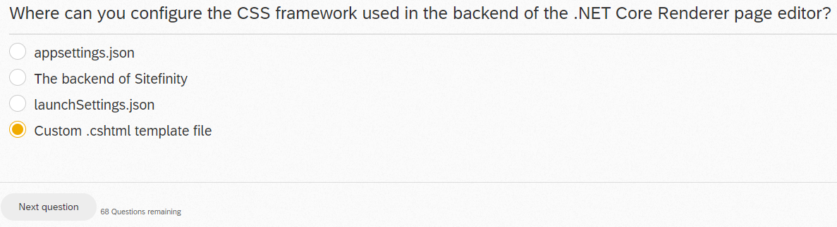

INCORRECT

How do you associate a custom widget designer, named DesignerView.Simple.cshtml with a widget?

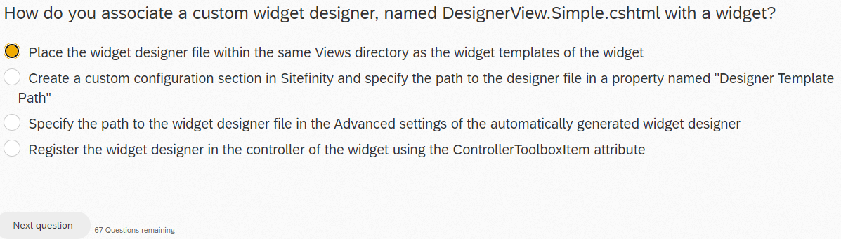

Which of the following is the proper postman URL used to query the API and filter to items where the “Title” property contains the word “news”?

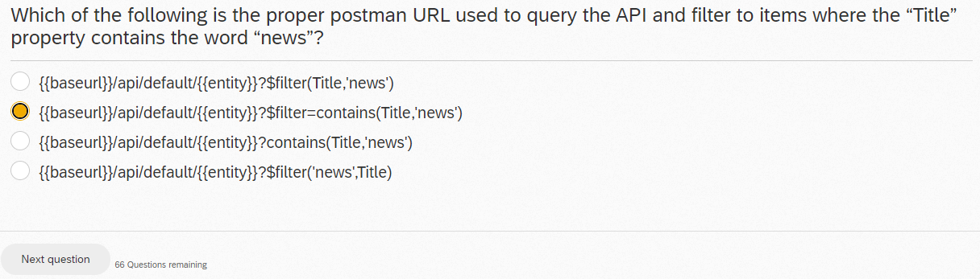

How do you associate an MVC widget designer view with its related widget?

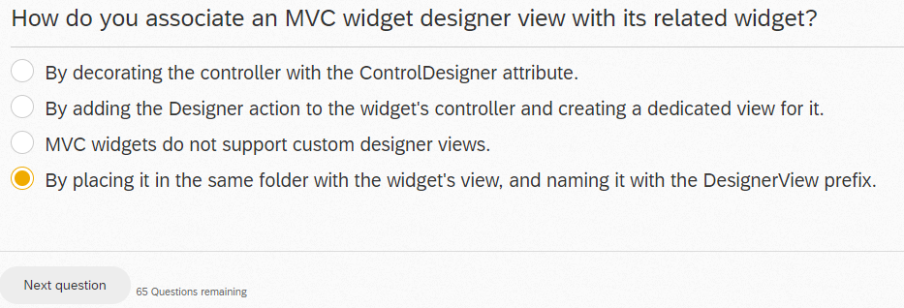

What interface do you need to implement on your Dto classes to utilize the Sitefinity IRestClient and interact with the OData web service?

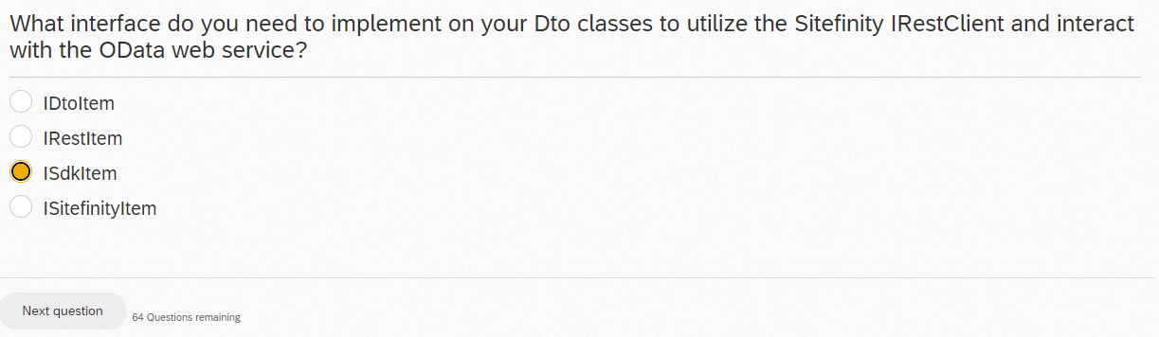

Which interface should be used to open a dialog from within a custom AdminApp extension?

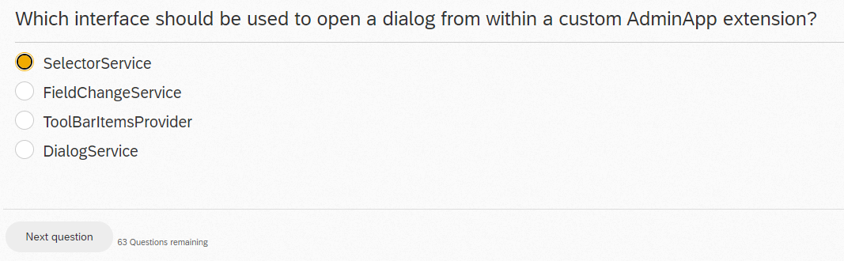

You need to add file-system storage support for your news articles, so that news articles are persisted as XML documents on the file system. You don't want to duplicate Sitefinity's existing functionality but rather extend what's already there. What is the proper solution?

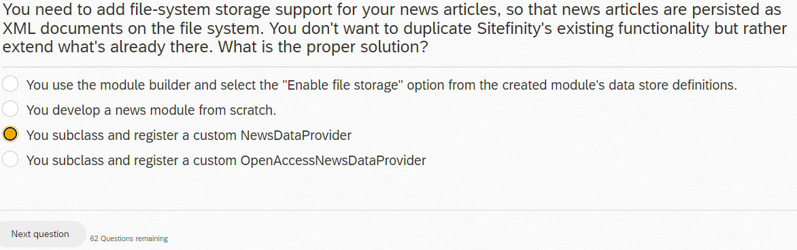

How do you access dynamic content items (content items that are associated with modules generated by the module builder)?

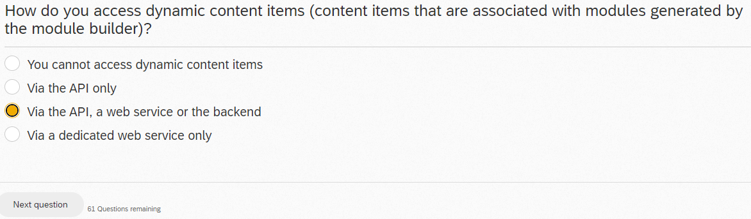

You are writing a custom Web service to be used for endless scroll of Event content items. You are developing for performance and need to figure out the basics of the Data access level. What code should you use to finish the snippet below to properly handle the paging of what is expected to be 1000+ items?

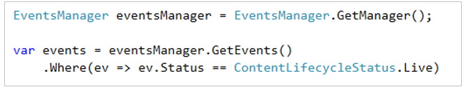

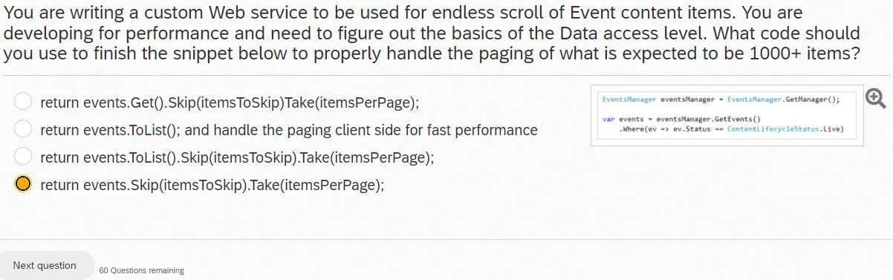

Which of the following statements are TRUE about page templates and layout files?

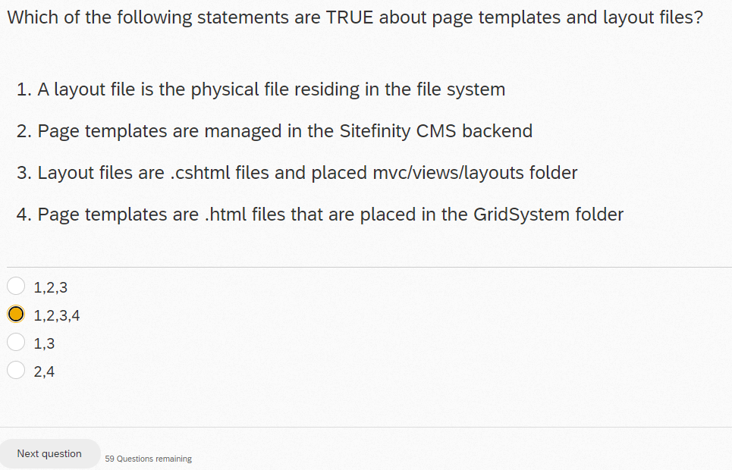

INCORRECT, try 1,2,3

Which of the following are advantages of using the CLI to upgrade Sitefinity?

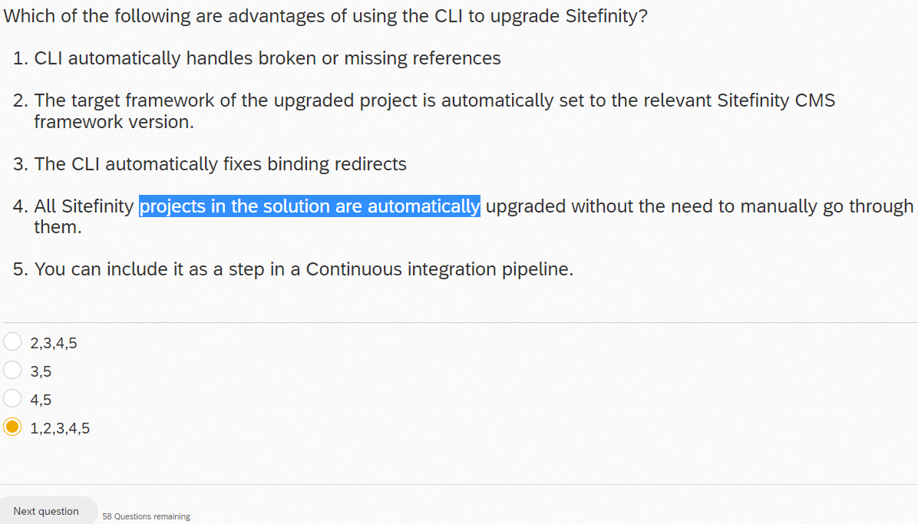

When querying a custom web service you have defined in Sitefinity, what querystring can you add to the API Url so that related field data is included in the JSON response?

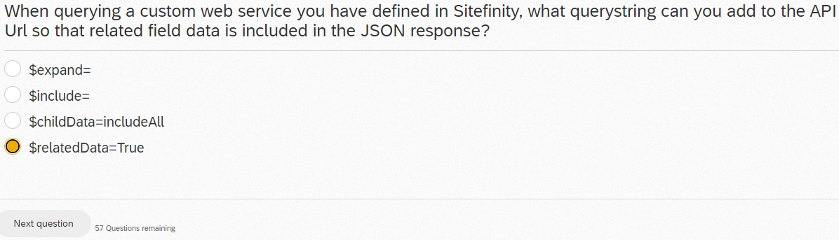

INCORRECT

Which layers of the application could be wrapped in a Sitefinity module?

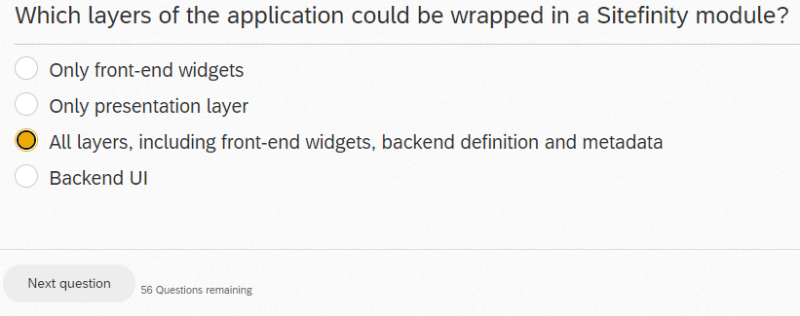

The majority of Sitefinity's Web services are accessible via:

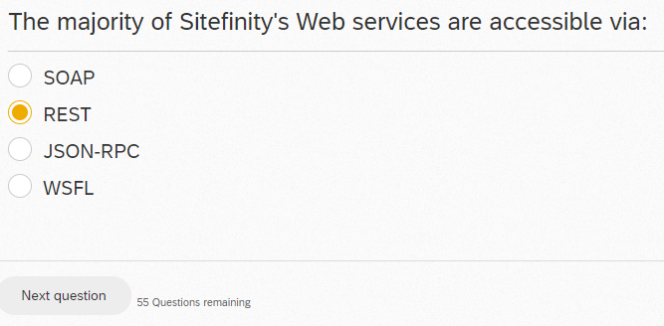

Your team has developed a lightweight CSS framework for responsive grids. As a Sitefinity developer, you have to advise on the best solution for using this CSS framework across many Sitefinity projects that will be started in the near future. What approach should you recommend?

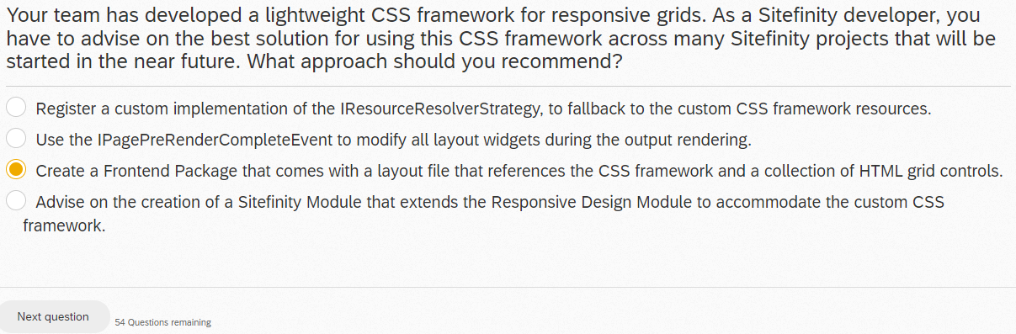

For better deployment and easier upgrades which of the following best practices should be adopted?

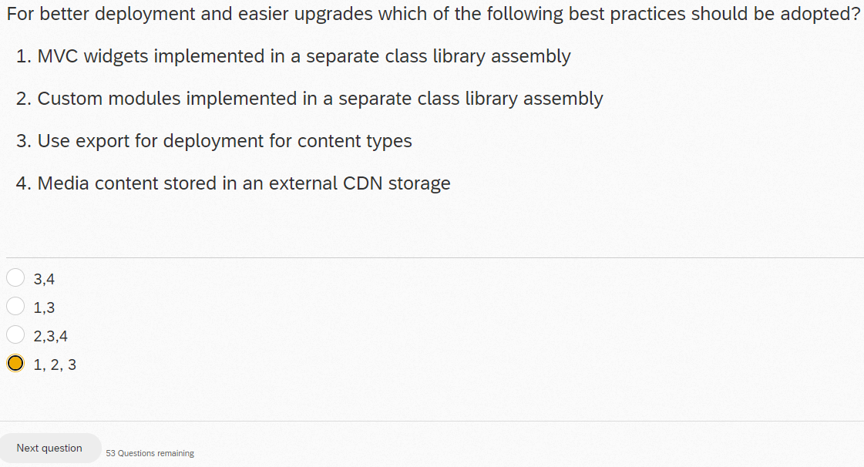

Which of the following statements are true about tags and categories in Sitefinity?

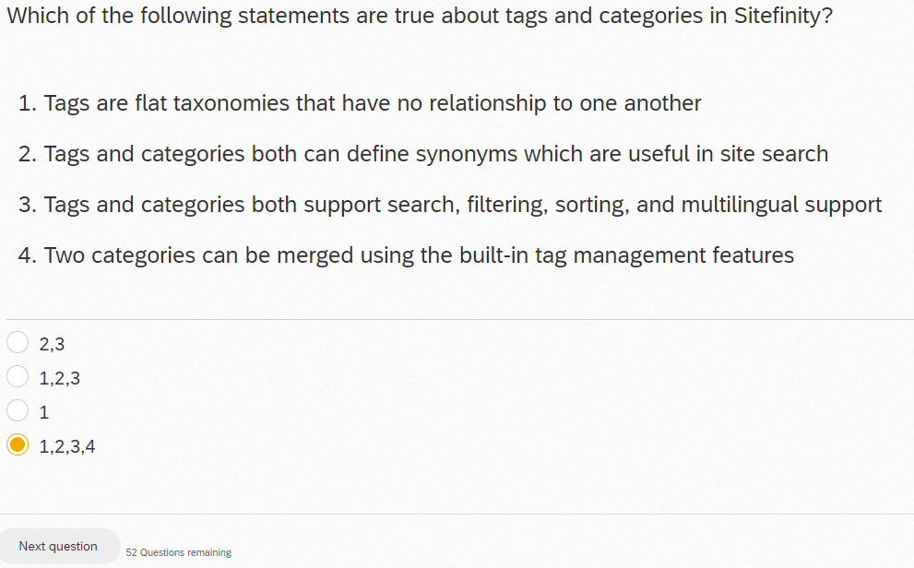

INCORRECT, try 1,2,3

How do you register your custom MVC controller as a widget in Sitefinity?

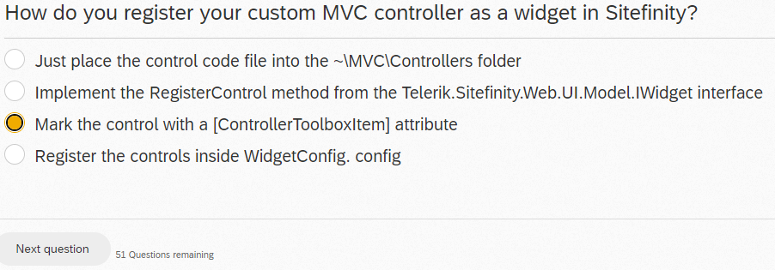

In a .NET core page template, the proper way to determine if the page is being loaded in the page editor is:

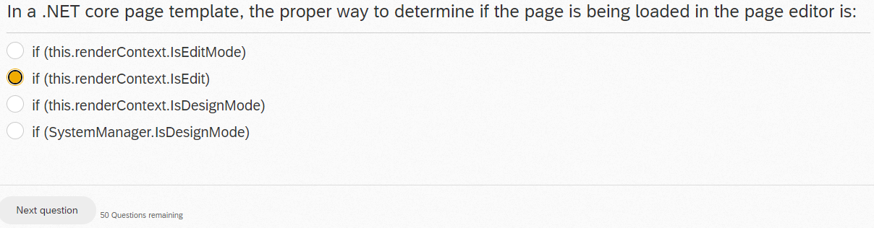

In which of the following locations can Sitefinity store configuration settings?

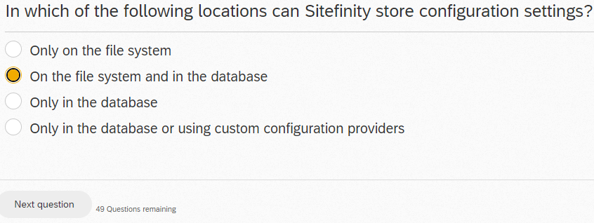

Pages created in Sitefinity (for example, in the backend or using web services) are persisted:

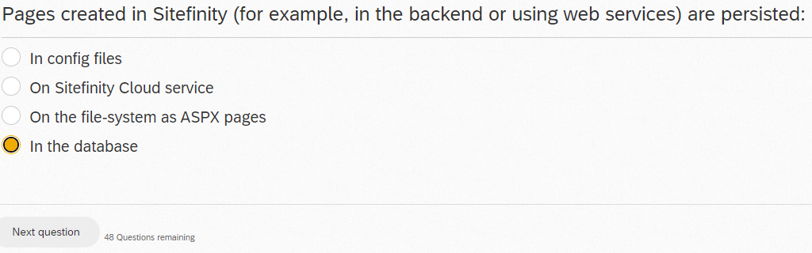

You have a page with two custom MVC widgets on it. One widget (Articles widget) has two actions - Index() and the FilterByTag(string TagName) - to display a list of items filtered by a taxonomy. The second widget (Promo widget) has only one action - Index() - which displays promo content on the page. You want the promo widget to always be visible even when users are invoking the FitlerByTag action of the Articles widget. What is the proper way of ensuring this?

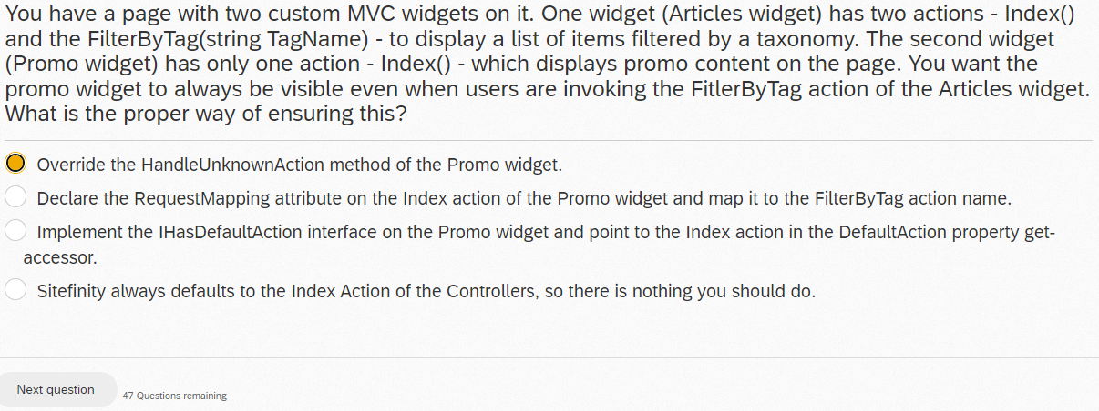

What is the correct method to retrieve an instance of PageManager in Sitefinity?

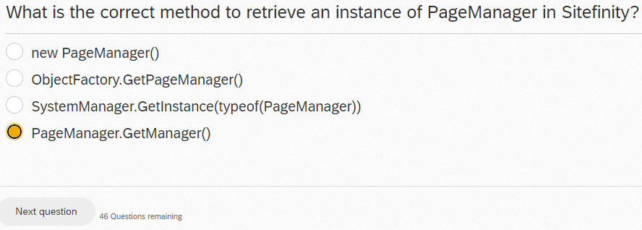

Which of the following is not true of Sitefinity multisite functionality?

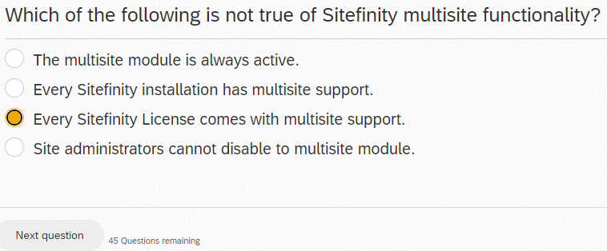

When creating a custom text field to be used on Sitefinity forms, which of the following should the controller of the form field inherit from so that the field can reuse logic for other form fields and also be used within the form rules manager?

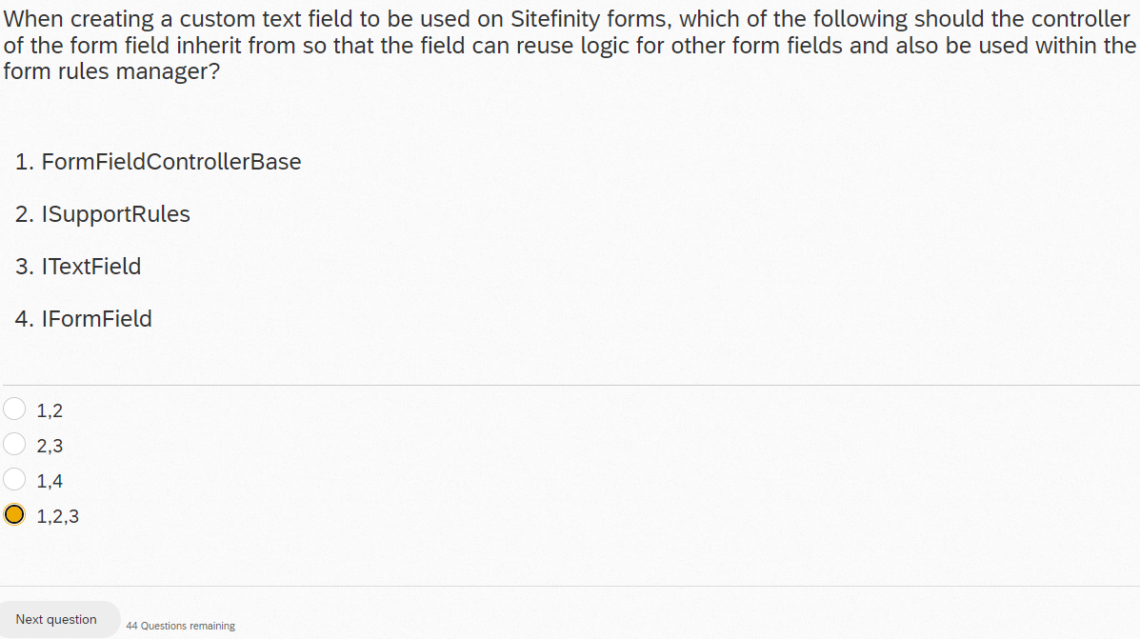

Which of the following is true of the built-in webhook mechanism?

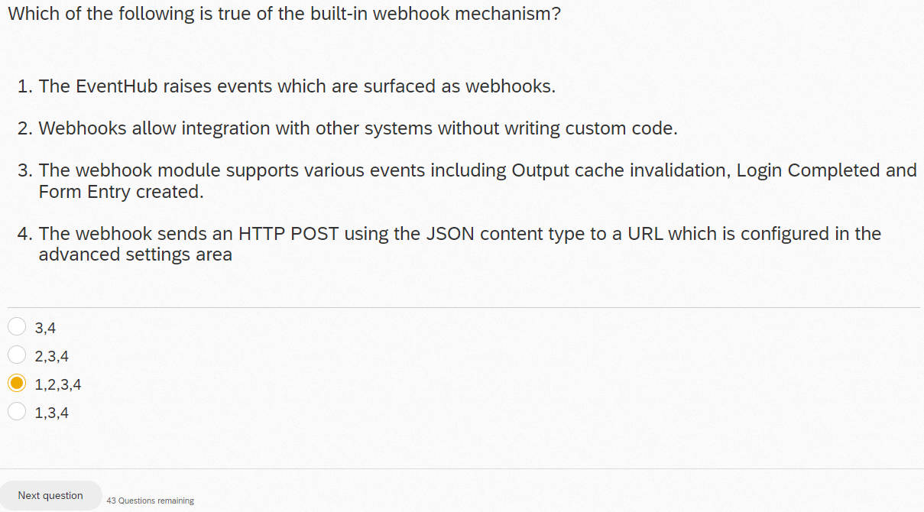

For enhanced security, what can you do to protect your saved custom configuration settings, which may contain sensitive information?

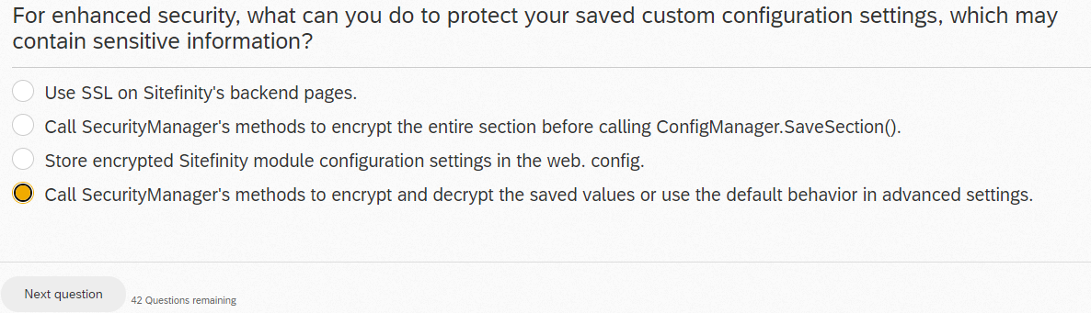

Sitefinity supports which of the following headless scenarios?

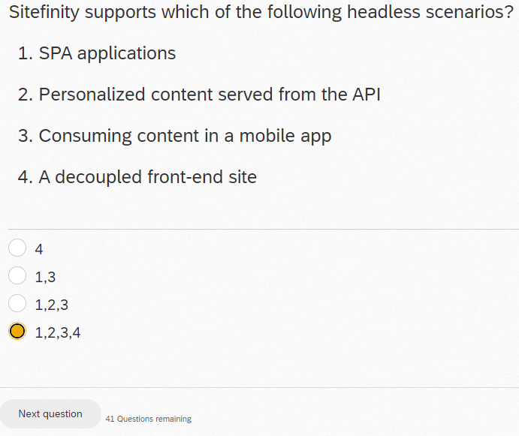

Which of the following statements about .NET Core page templates are true?

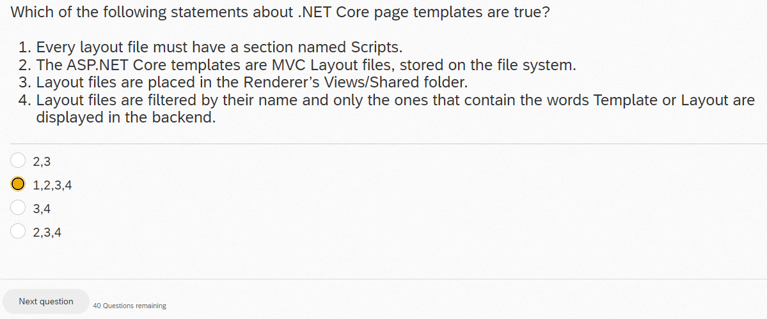

How do you write your own error/trace/debug messages to Sitefinity's proprietary log files?

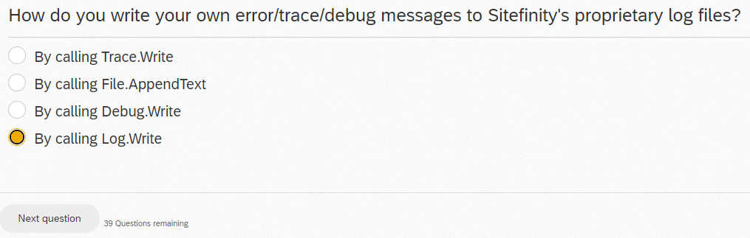

You are tasked with developing a SalesForce integration. After analysis, you conclude that you will need to implement four different MVC widgets that will be querying the same SalesForce application. Users will also want to be able to switch to a different SalesForce account should they need to. What is the recommended way of storing the SalesForce-related connection credentials?

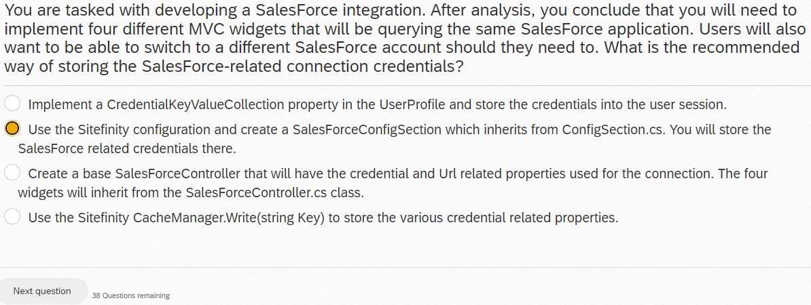

The Sitefinity .NET Core Renderer can serve which types of content pages?

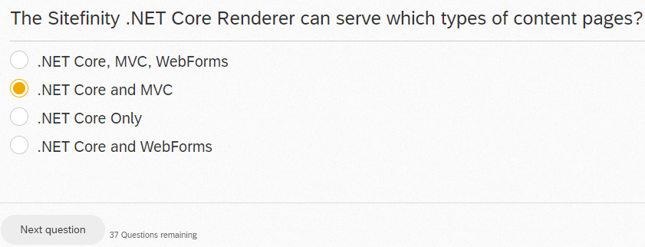

INCORRECT, try .NET Core Only

A content item's dynamic fields (also known as meta fields) can be accessed:

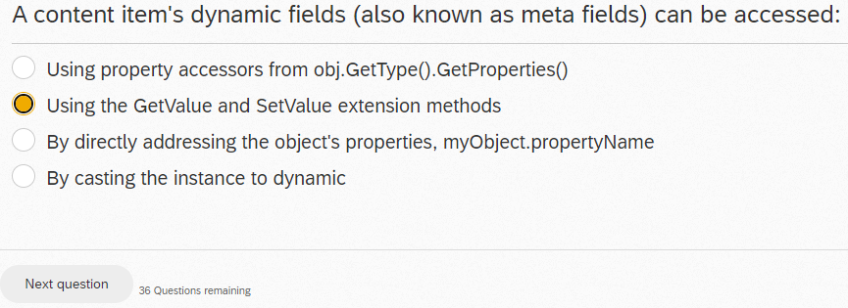

You have been asked to review a Sitefinity application that was just upgraded. You have been given application credentials and access to the hosting web server. Where would you first check to see if the upgrade has successfully completed?

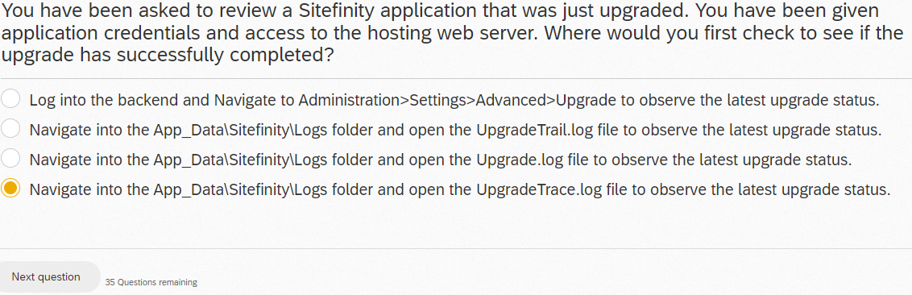

What does the ResourcePackages folder contain?

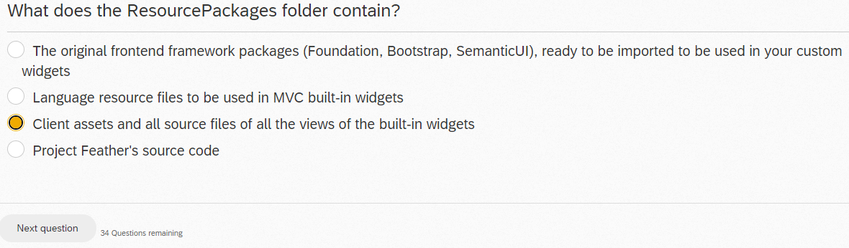

What are some challenges which are solved by setting “read only” mode for configuration values?

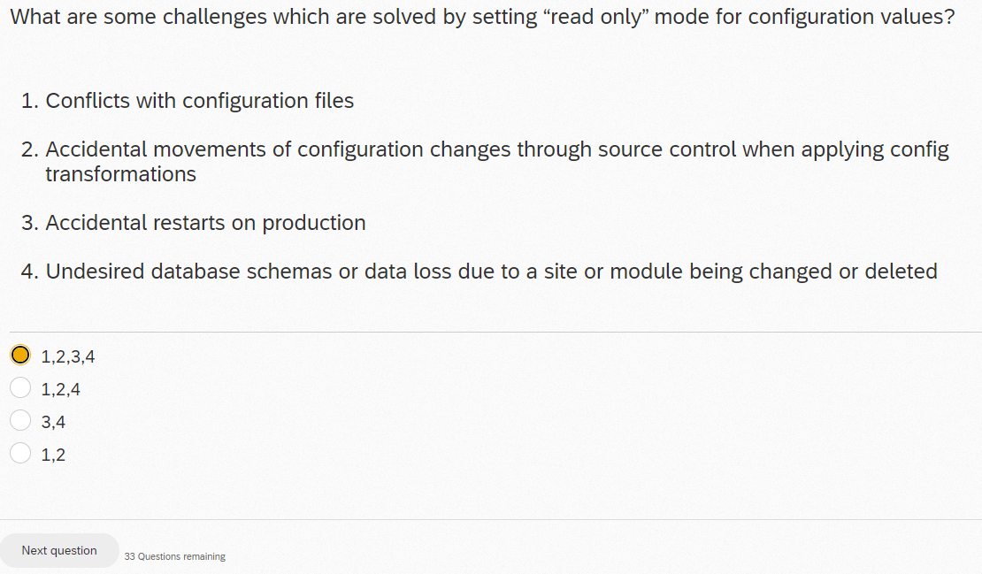

When creating multiple custom fields in the AdminApp Extensions project, it is not possible to register all of the custom fields within a single provider. Instead, you must create a different provider for each custom field.

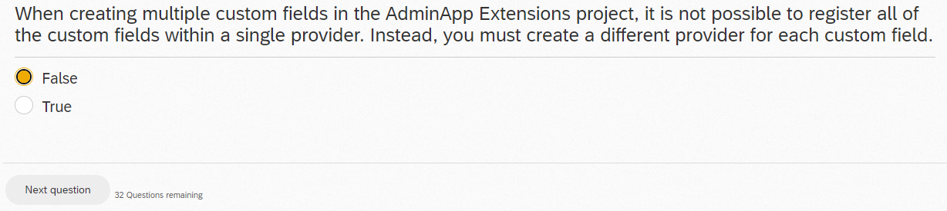

When performing a Sitefinity upgrade via the Command Line Interface (CLI), which of the following is the proper command to enter?

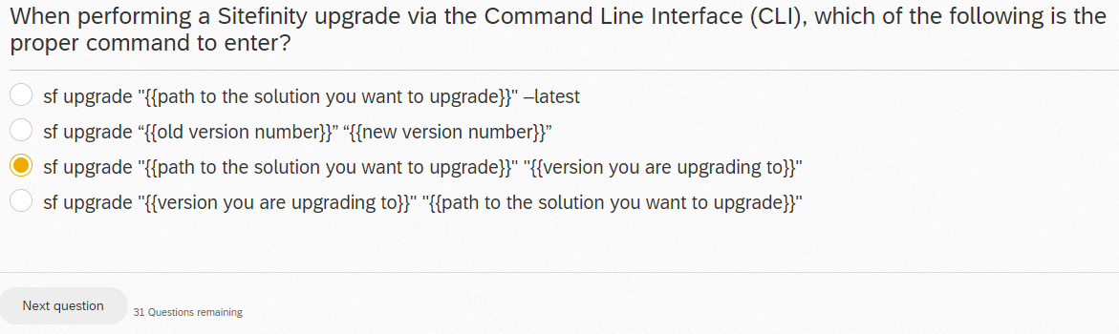

For the three types of APIs in Sitefinity: Native, Fluent, and REST, which statement is NOT true?

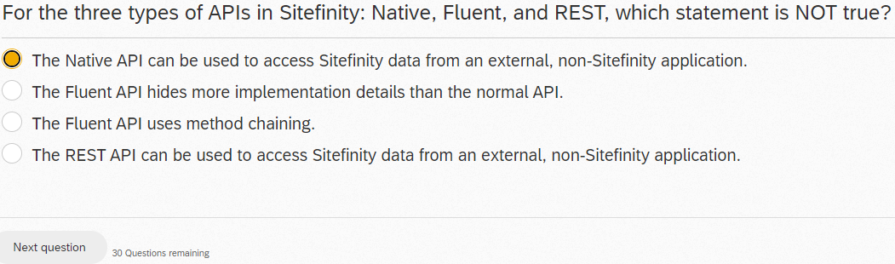

Can new dynamic content types be automatically added to the OData webservice response object?

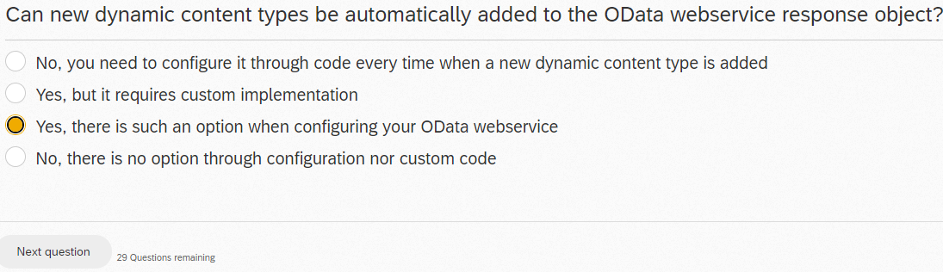

You want to create a new Widget Designer for a custom MVC widget. What do you need to do?

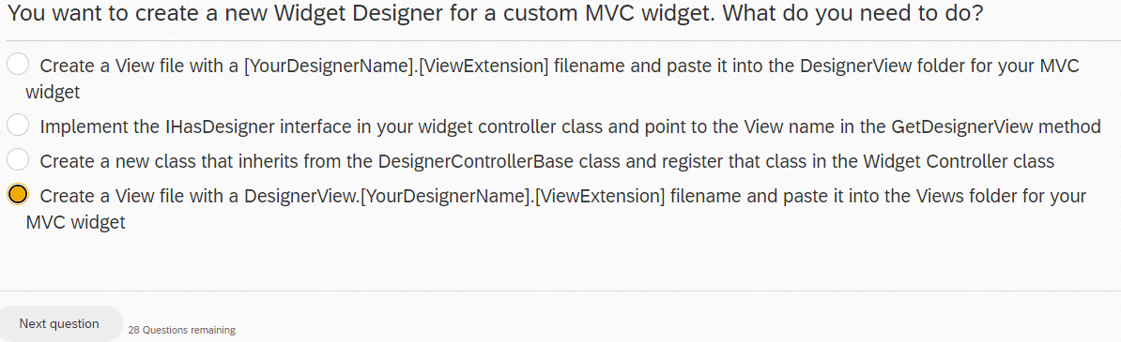

When customizing the autogenerated fields on widget designers, how can you hide the field from the property editor?

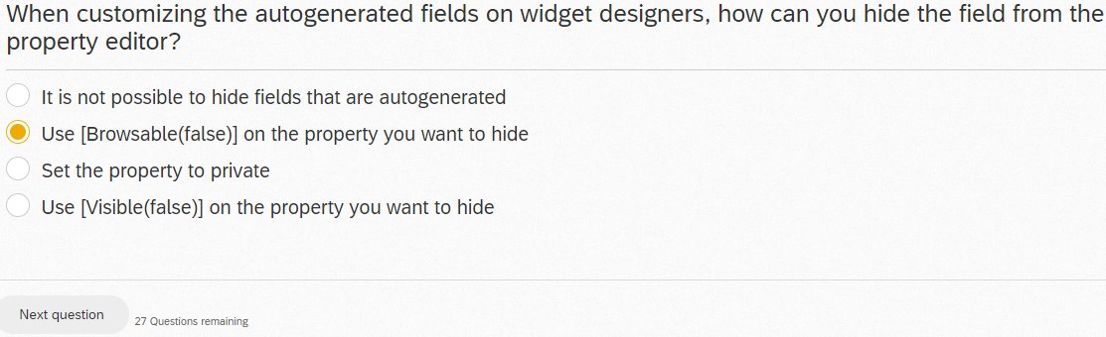

What are possible drawbacks of the Fluent API?

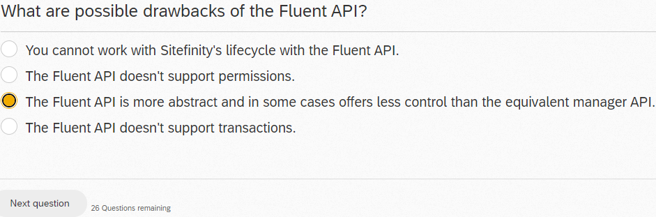

You are monitoring a website built using the recommended MVC mode that has performance issues. After some research, you see that the main problem is that there are a lot of Javascript files (50+), which are loaded separately and many times more than once. What is the one action you should recommend?

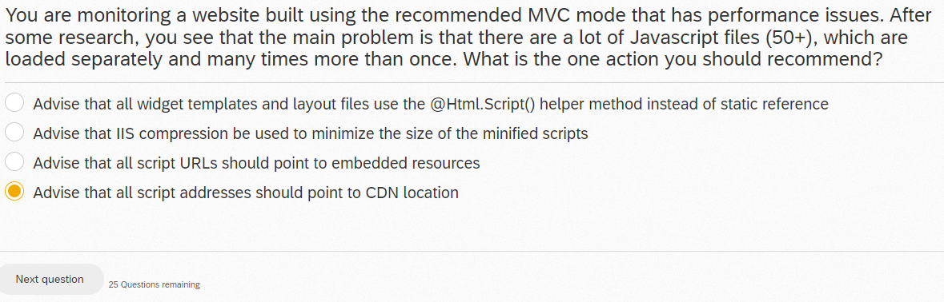

INCORRECT

On production sites, which of the following should you do to improve performance?

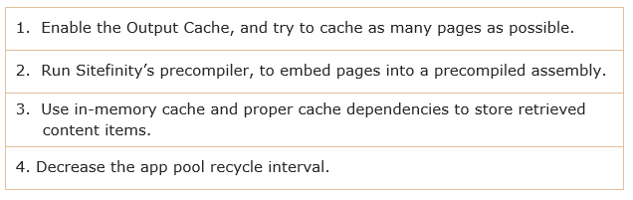

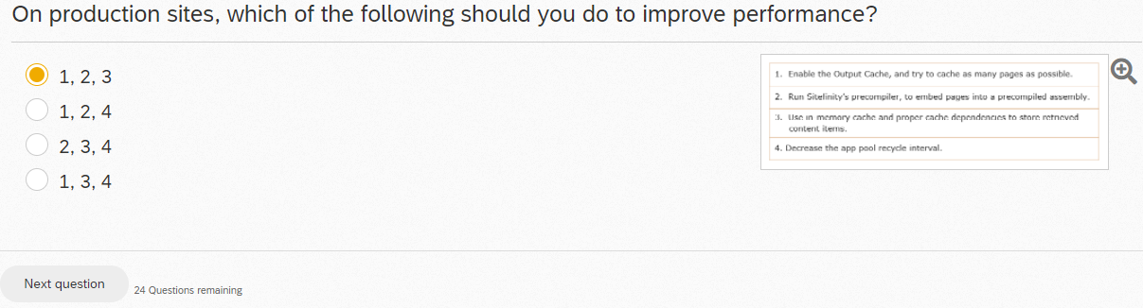

You want to integrate an existing MVC app into Sitefinity, but you want to enable the content editing capabilities for the page editors on top of the MVC app. What is the recommended approach?

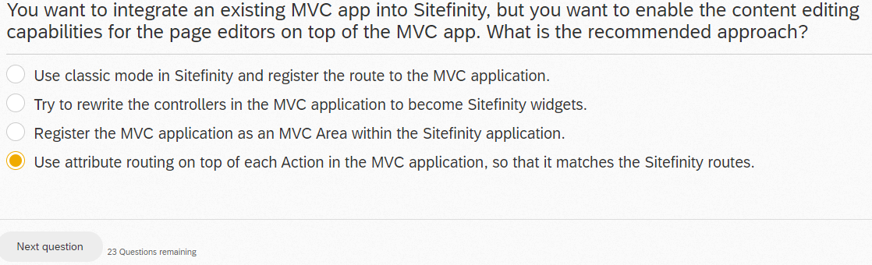

INCORRECT, try Try to rewrite the controllers in the MVC application to become Sitefinity Widgets.

Installing Sitefinity by using the “Progress.Sitefinity” NuGet package has the following advantages:

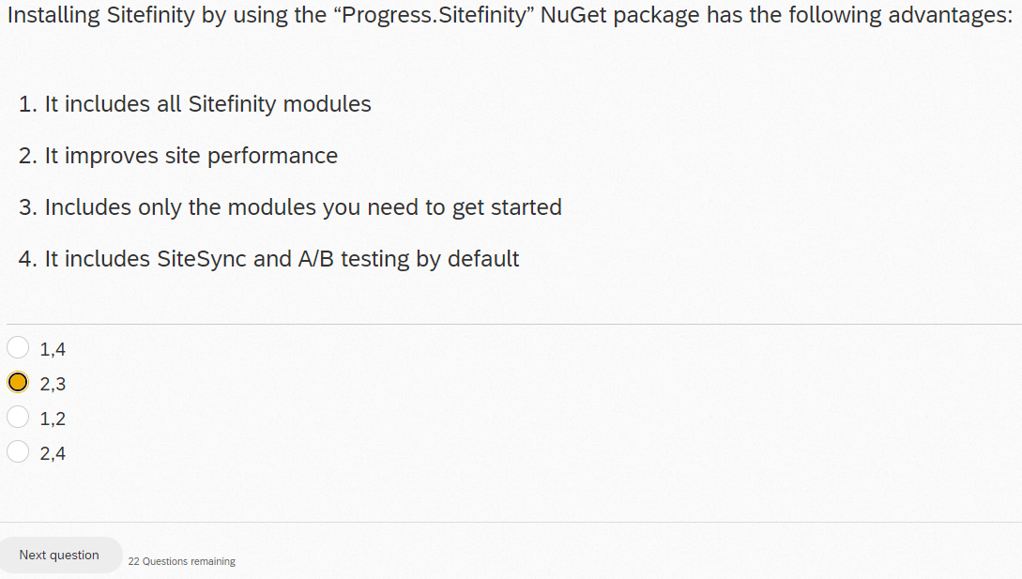

The output cache for OData services is supported for which of the following requests?

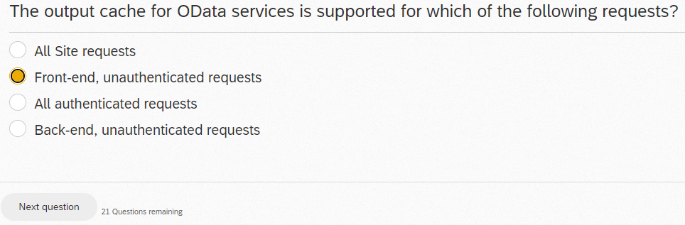

Which of the following steps do you have to perform to register a custom configuration class in Sitefinity?

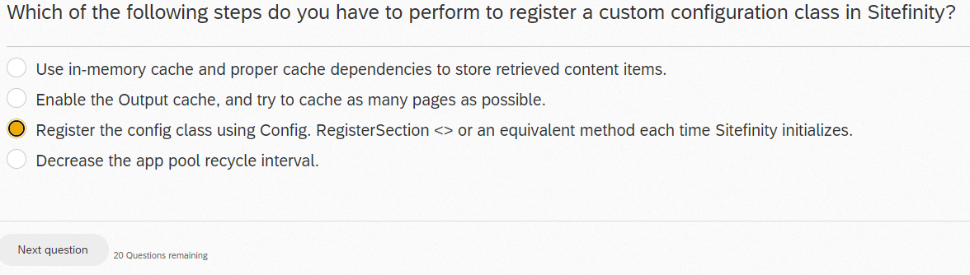

Sitefinity allows which of the following customizations to the admin app?

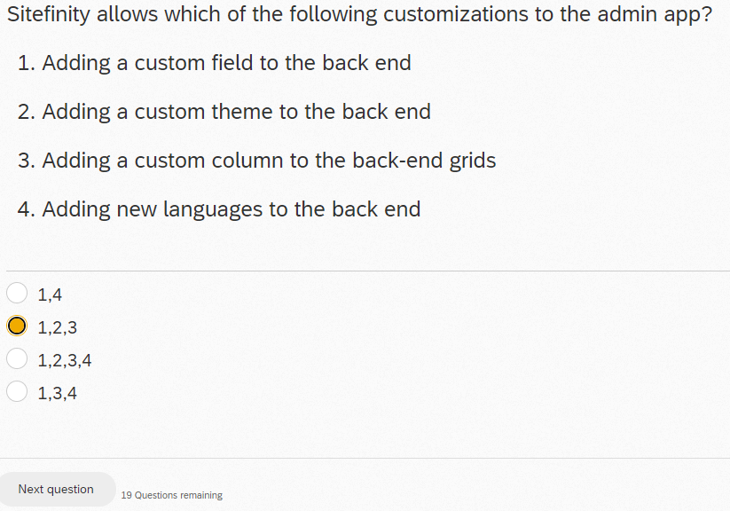

You have created a new HTML template for a grid widget. What do you need to do to make it available in Sitefinity?

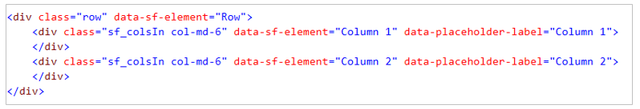

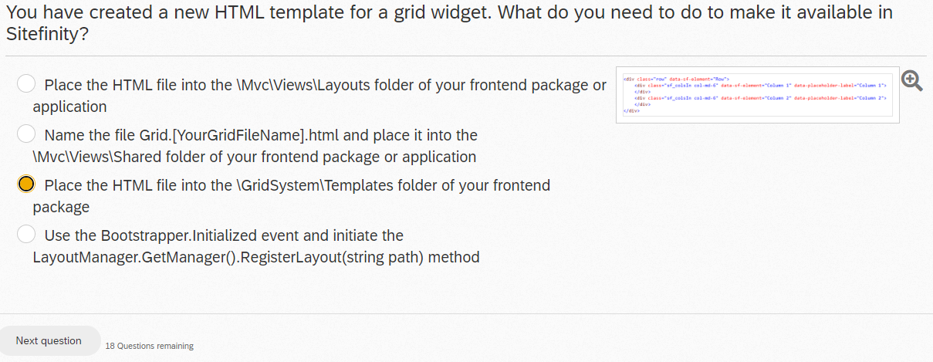

You want to add additional fields to Sitefinity's news article data model. What is the proper solution?

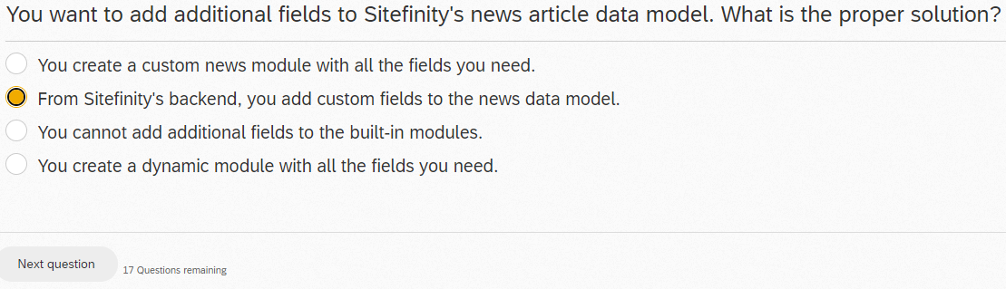

Which parts of a dynamic module are created automatically by Sitefinity?

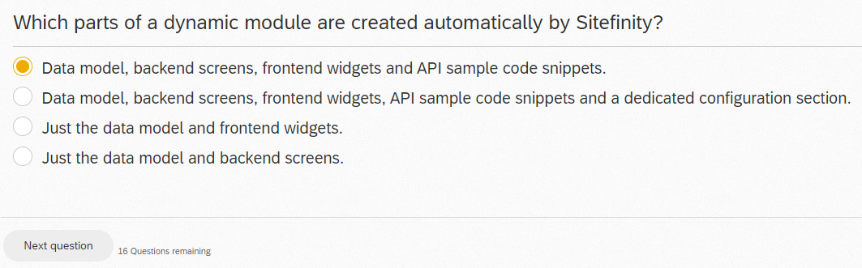

Blob storage providers:

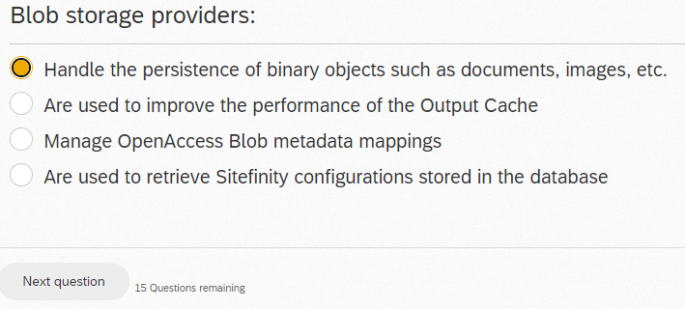

Which of the following is a benefit of the Fluent API?

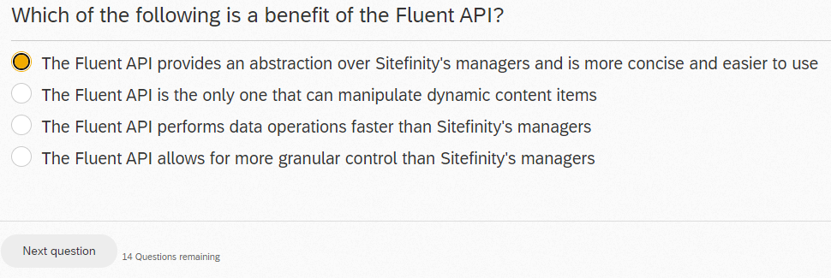

What will be the effect of this code?

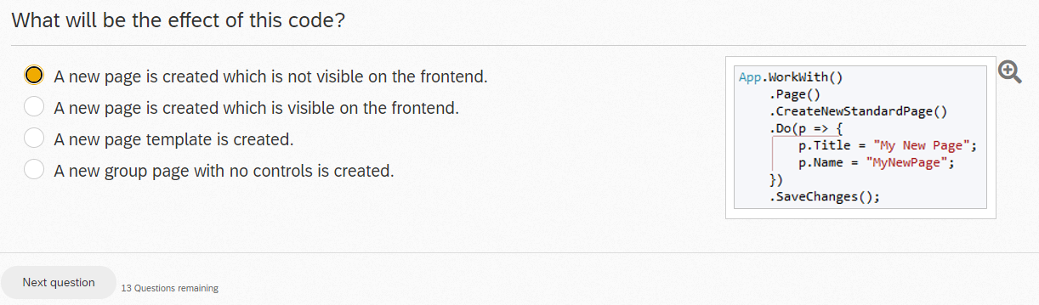

The OpenAccess L2 cache is:

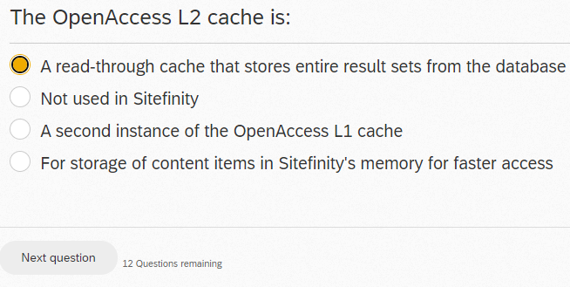

Which of the following is not true of the Sitefinity .NET Core Renderer architecture?

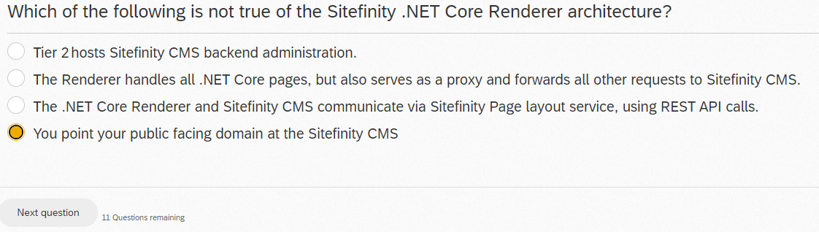

When working with autogenerated field types on widget designers, what is the MixedContentContext used for?

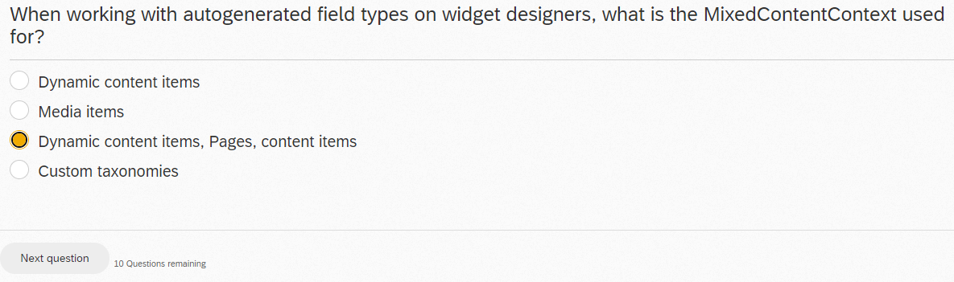

What is the purpose of Sitefinity VSIX?

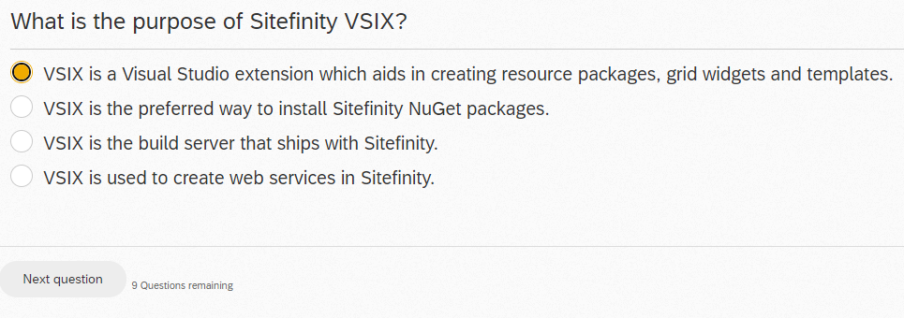

In which order does Sitefinity attempt to resolve the location of the view for a widget template?

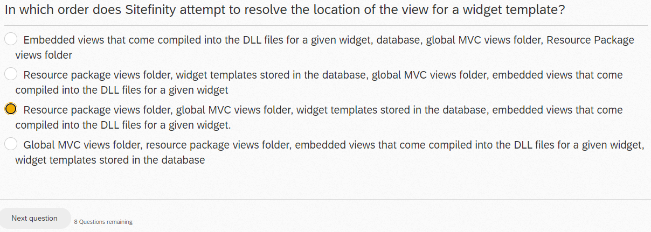

Sitefinity uses which of the following technologies?

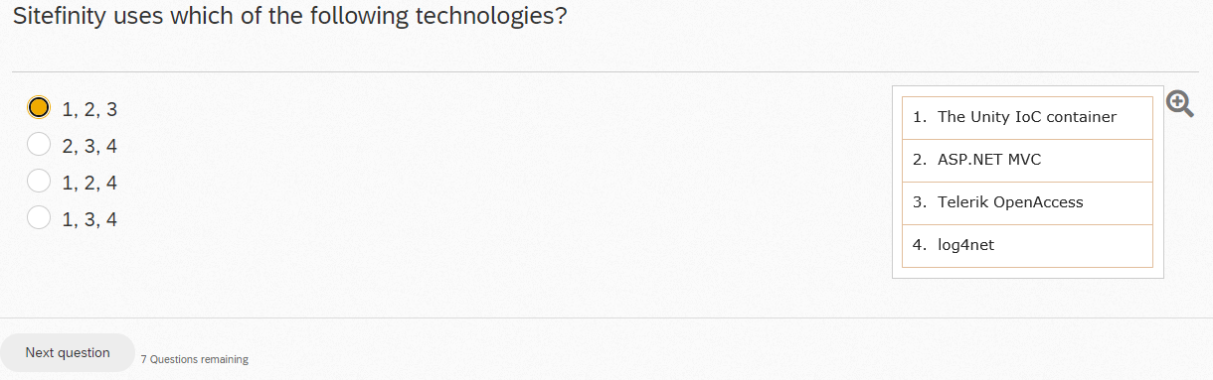

For communicating with OpenAccess, where is common functionality implemented in all relevant data providers?

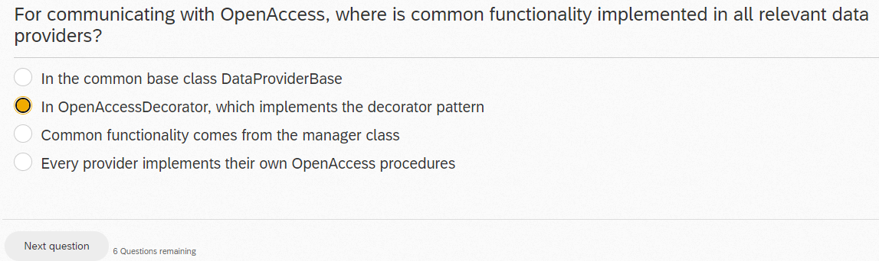

What types of custom Web services can you create and run in Sitefinity?

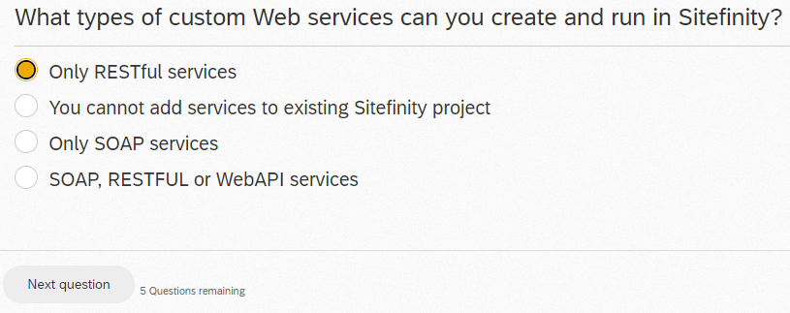

INCORRECT, try SOAP, RESTFUL or WebAPI services

You are building a custom frontend package and your task is to add a new View for the out-of-the-box MVC News Widget. The view will be used to display a rotating selection of the latest five new items published. What filename convention do you need to use?

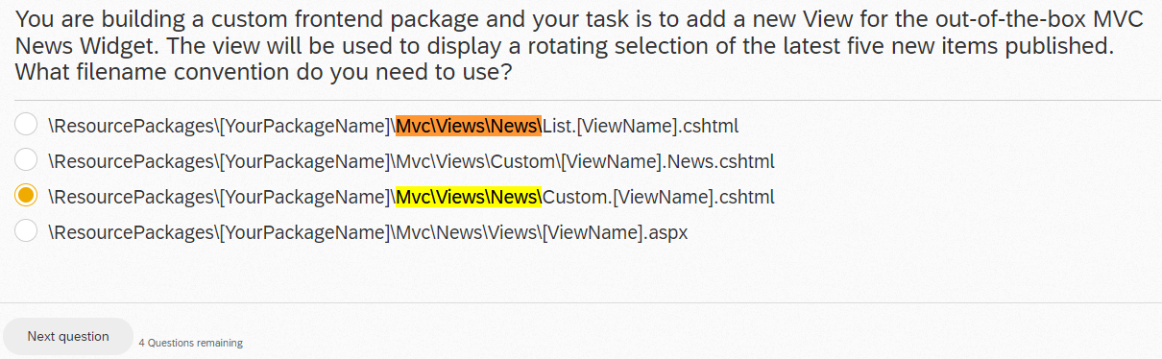

INCORRECT, try \ResourcePackages\[YourPackageName]\Mvc\Views\News\List.[ViewName].cshtml

How do you change the name of the AdminApp Extensions bundle that is created when compiling the AdminApp Extensions project?

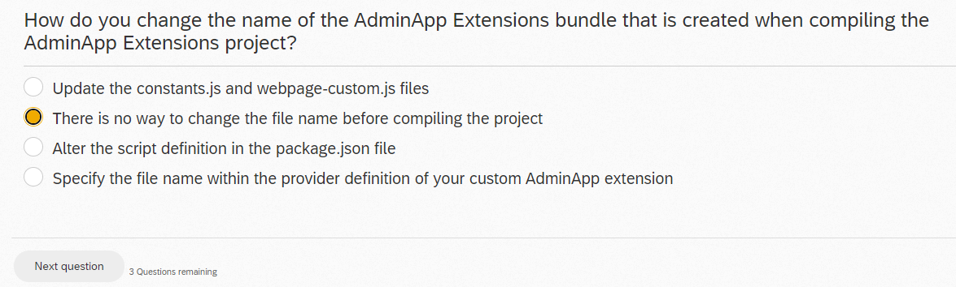

INCORRECT

Which of the following actions do you NOT need to manually perform during an upgrade of a Sitefinity project?

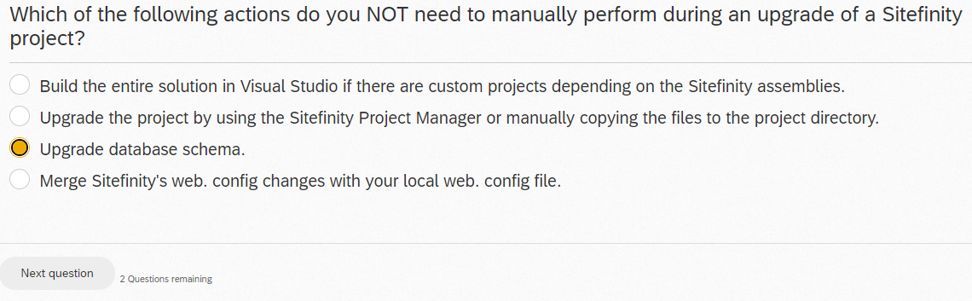

How can the Diagnostics module help you improve your deployed Sitefinity project?

